**NAME: MANI SAI MENDA**

**REG NO.:192111399**

**COURSE: DATABASE MANAGEMENT SYSTEMS FOR DATA ANALYTICS.**

**COURSE CODE: CSA0520.**

**Ex.No 3 DML Commands – INSERT, SELECT, UPDATE, DELETE**

**Questions**:

1. Populate all the five tables with your own data

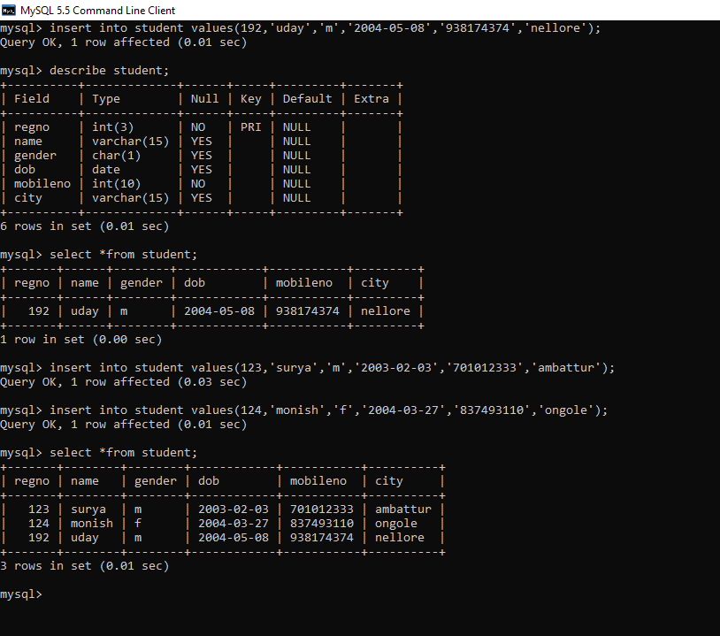

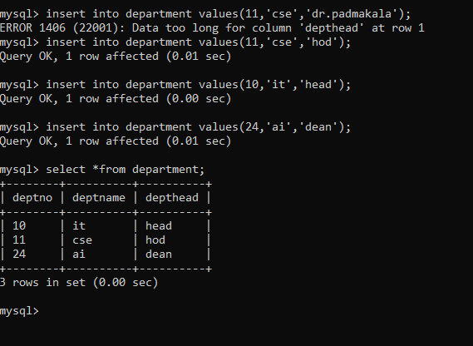

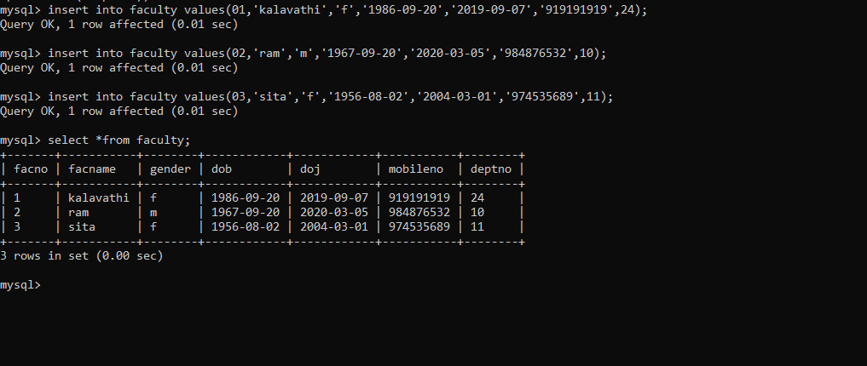

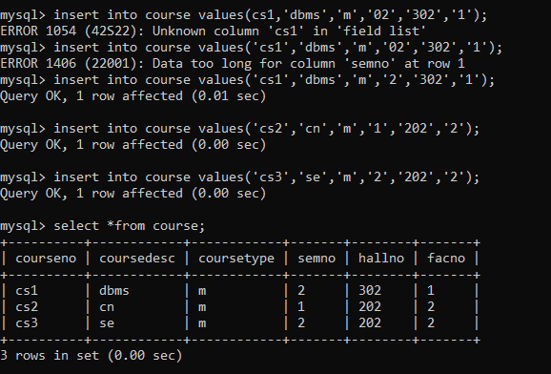

2)Update the value of student name whose register number is ‘124’

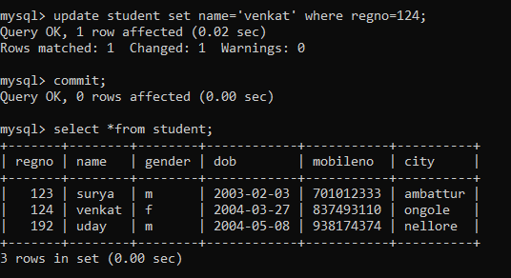

3)_Delete the record in the table FACULTY, who resigned her job.

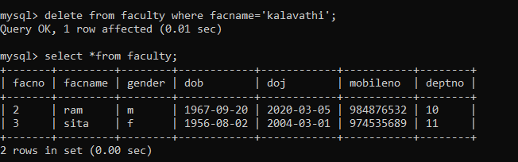

4)Modify the date of birth for the faculty whose name is 'RAM' with a value ‘1983-05-01’

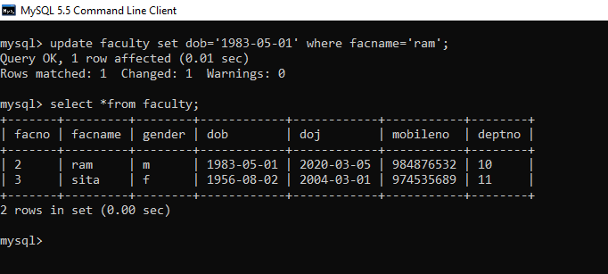

5)Remove all faculty who are having over 65 years

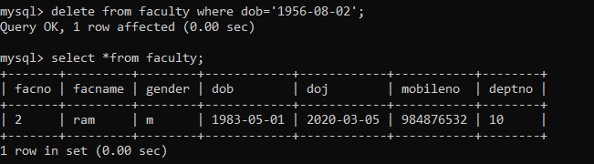

6)View all the records from the five tables.

